Echo $JAVA_HOME

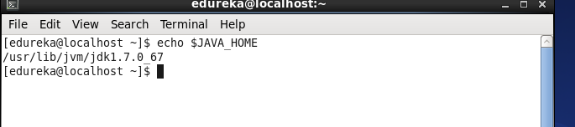

Run **vi .bash_profile**

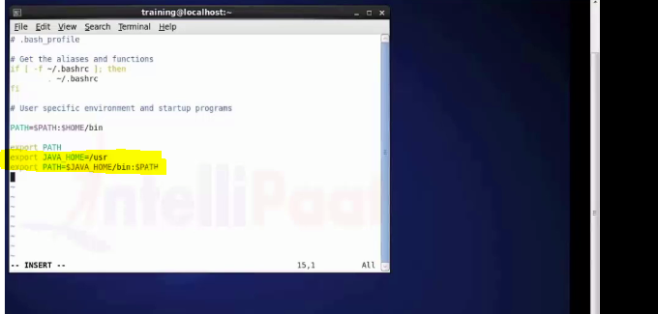

Run command **source .bash_profile**

Nothing will come up

Run command **sudo /etc/hosts**

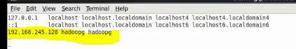

Give the ip address here of virtual macgine here.

6. sudo hostname hadoopg

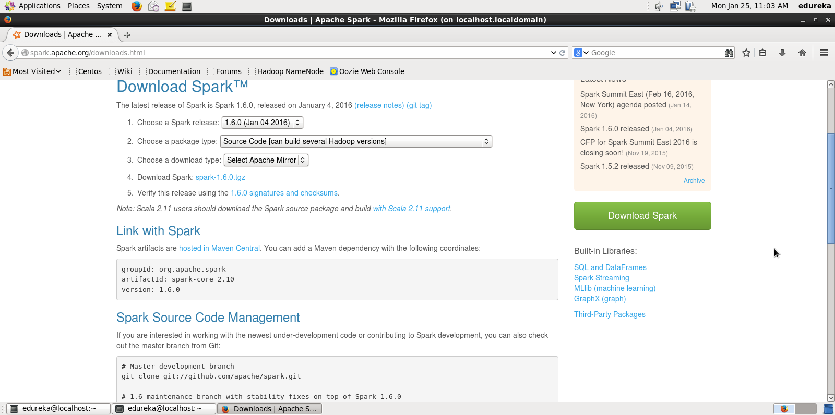

After untaring , run the command after going inside spark folder

